Using a qualitative model to explore the relative impacts of ecosystem drivers in declining marine survival in Pacific Salmon

K. Sobocinski, C. Greene, M. Schmidt

v.3

November 21, 2016

# Introduction

Problems of complex interactions are common in many fields, including medicine, economics, and ecology (Levins 1974). In ecology, much attention has been given to describing foodwebs and interactions among species (May 1974, Paine 1966, Pimm et al. 1991, Dunne et al. 2002). But often, these foodwebs are nested within larger ecological or social-ecological contexts where exogenous forces influence components of the foodweb system. External forcings may include physical drivers, anthropogenic impacts, or ecosystem components that are not characterized within the focal network. In social-environmental systems, tools that incorporate abiotic variables and management actions within the same analytical framework are needed to accurately understand the dynamics of complex systems and evaluate potential management actions. While complicated end-to-end models such as *Atlantis* are coming to the forefront in marine ecosystem management (Ainsworth et al, 2010, Fulton et al. 2011) these models are complex, data-intensive, and require high levels of expertise to develop and run. Here we use qualitative network analysis, a conceptually-based, data-free modeling approach, and a suite of simulations to address questions about the relative impacts of human and natural influences on early marine survival of juvenile salmon in the Salish Sea.

In recent years, attention has turned to early marine life-history stages of Pacific Salmon in an effort to understand population declines and failure to rebound given myriad conservation and restoration efforts in freshwater streams. In Chinook, Coho, and Steelhead salmon (*Oncoryhchus tshawytscha*, *O. kisutch*, and *O. mykiss*, respectively), declines in survival have been evidenced within Puget Sound, WA, USA and the Strait of Georgia, Canada that have not been seen in coastal populations (Johannessen and McCarter 2010, Zimmerman et al. 2015, Kendall et al. XXXX, Ruff et al. XXXX). These water bodies, collectively the Salish Sea, serve as habitats for juvenile salmon as they pass from natal streams to ocean waters during their outmigration period. Yet, because of complex anthropogenic changes brought about by climate change, population increases, land use change, and human activity in these coastal waters, it is likely that a number of factors and their cumulative—synergistic or additive—effects are contributing to increasing marine mortality. Other salmon species, such as Chum, Pink and Sockeye salmon (*O. keta*, *O. gorbuscha*, and *O. nerka*, respectively), have not experienced similar declines (Figure 1), suggesting that life-history characteristics may contribute to increased mortality for some species in this region. Teasing apart which of these factors have negatively impacted survival of juvenile salmon in marine water waters is of concern to local, regional, and federal governments and other stakeholders (e.g. Salish Sea Marine Survival Project, <http://marinesurvivalproject.com/>) and management actions are desirable to lessen impacts and increase survival during this period.

While correlative studies of salmon abundance and environmental factors have been on-going in the greater region for many years (Pearcy 1988, Beamish et al. 2000, Teo et al. 2009), new focus is being paid specifically to early marine stages and impacts including oceanographic and environmental conditions, anthropogenic impacts, and foodweb components within the Salish Sea. In addition to focus on oceanographic conditions and salmon, foodweb models have been developed for the Strait of Georgia (Priekshot 2008) and Puget Sound (Harvey et al. 2012). These models show the importance of primary production for driving the biological system, but also the effect of top predators in creating trophic cascades and influencing foodweb dynamics in the mid-trophic levels (Harvey et al. 2012), where time series data are sparse. But even with an understanding of the main interactors, or variables, in a given system, measuring abundances of each variable and the flux of material/energy/data etc. among them often poses a logistical challenge (Christensen and Walters 2004). It is the rare system that is ever completely specified (Levins 1974). For this reason, conceptually-based models, incorporating a broader array of variables, are an important tool in modeling and can provide a holistic picture of ecological and human drivers of ecosystem change.

One tool for evaluating the relative influence of ecosystem components is Qualitative Network Analysis (QNA, also called Qualitative Network Modeling, QNM, or Loop Analysis, Levins 1974, Raymond et al. 2011, Melbourne-Thomas et al. 2012). This approach is advantageous for understanding a system of complex interactions which may not be fully specified and when precise measurement is impossible, but when a mechanistic understanding of interactions exists. It also allows the testing of competing hypotheses, given different model structure or the invocation of perturbations to one or more of the model variables. QNA does not explicitly include magnitudes or non-linear direct effects, both of which occur in and influence social and ecological systems. However, QNA may help to determine the relative impacts of competing hypotheses or what variables should be measured to improve system understanding (Levins 1974), focusing additional research efforts.

Researchers have used QNA for evaluating ecosystem response to ocean acidification in shellfish management (Reum et al. 2015), the impacts of eutrophication and species management within a foodweb (Carey et al 2013), and for discerning the impact of management actions for species recovery (Harvey et al. 2016) in the Pacific Northwest. QNA is an important conceptual tool for discerning relative impacts of ecosystem components. Here we apply this technique to evaluate a suite of potential drivers thought to be contributing to increased early marine mortality in a suite of Pacific Salmon. We invoke perturbations to a number of model variables and assess response in model compartments related to the salmon species of concern.

# Methods

We used QNA to address our main question of the relative impacts of various factors on salmon early marine survival. Our analysis had three main steps: 1.) Construct an enhanced conceptual model showing positive, negative, and neutral relationships using a digraph; 2.) Generate a pool of simulated models, with random weights applied to each model linkage; and 3.) Invoke one or more perturbations based upon mechanistic understanding of the system and determine the model response. We describe these steps in detail below.

## Conceptual Model

To construct our conceptual model of the Salish Sea system, we gathered experts and literature on ecosystem components and iteratively developed a working conceptual model. We began by developing a list of over 40 possible variables to consider. These variables were drawn from hypotheses about the decline of Pacific salmon within the system (Salish Sea Marine Survival Project hypotheses, <http://marinesurvivalproject.com/the-project/key-hypotheses/>) and included physical forcings (e.g. sunlight, precipitation), biological components from primary production (e.g., diatoms) to top predators (e.g. marine mammals, piscivorous birds) and competitors (e.g., forage fishes, piscivorous fish) and anthropogenic variables (e.g., hatcheries, habitat loss). Central to the model were the salmon characteristics: size, fitness, residence time, abundance, and survival. Survival was our primary response variable; however, by including individual traits we could evaluate the relative impact of model variables on different metrics of salmon performance. We grouped the model variables into several major driver groups: environmental factors, primary production, foodweb interactions, and anthropogenic impacts, in addition to salmon characteristic variables (Table 1). Focusing on physical, bottom-up, top-down, and anthropogenic factors fit with the working hypotheses of the Marine Survival Project and enabled exploration of combinations of variables and drivers while including fundamental processes and relationships within the ecosystem (e.g., sunlight and nutrients positively affect primary production, habitat loss negatively affects salmon and forage fishes, etc.). While the conceptual model is not exhaustive, it does include many of the drivers that have been hypothesized to impact salmon survival.

The emphasis of the modeling effort was on understanding sources of reduced survival and fitness of the focal salmon species (Chinook, Coho, and Steelhead). We included a model variable “other salmon” because the migration timing of all Pacific salmon species means competitive interactions are likely. However, the species included in the “other salmon” variable, Pink, Chum, and Sockeye salmon, have not experienced the same decline in survival and were seen as important to the analysis but somewhat ancillary. While the emphasis was in representing the most direct impacts to the focal salmon traits, we recognize that many of the model variables (e.g., temperature) could potentially have direct connections to other model nodes; we have included these where interactions were important for understanding implications for the focal salmon variables.

The inclusion of model compartments that are not biomass pools highlights the flexibility of qualitative models. We defined relationships among variables as positive, negative, uncertain, or null, and these relationships were based upon mechanistic understanding of the Salish Sea system. To implement the simulation modeling, we developed a conceptual digraph using the directed graphing software, Dia (v.0.97.2), to represent the model system and the interactions among variables (Figure 2). This digraph served as the foundation for our qualitative modeling.

## Simulated Networks

We used the *QPress* package for Qualitative Network Analysis (Raymond et al. XXXX) with custom modifications in R (R Core Team 2016) to interpret the conceptual digraph and construct simulated networks. Given a network model, this package provides routines for evaluating the impact of a press perturbation to the system through simulation. We simulated the network ~120,000 times to result in 10,000 stable simulated networks. For each simulation, a weight (drawn from a random uniform distribution, 0-1) was assigned to each linkage (edge). These weights were positive or negative depending upon the relationship between the two endpoints. If the resulting model with the assigned weights was stable, the model was accepted.

To assess the sensitivity of the model linkages in the *QPress* simulations, we calculated means and standard deviations of the weights for all links from the pool of accepted models. Our hypothesis was that some linkages would be more influential in model stability and that those with mean weights different than the expected mean (µ=0.5, given assignments that were random (*U(0,1)*)) would provide some indication of linkage sensitivity. We experimented with changing both distribution and the variance of the weighting scheme, but did not find large differences in results, so maintained the default weighting for our analyses. Additionally, we described network properties such as connectance and linkage density and calculated distance to the Survival node via pathways from each model variable.

## Invoking Perturbations

To test a suite of hypotheses concerning drivers to the Salish Sea ecosystem, we developed *a priori* perturbations to invoke upon each model node (Table 1). The direction of the perturbation (increase or decrease) was based upon our understanding of the system, changes that have occurred concomitant with declines in salmon marine survival (since the 1970s), and expected impacts as a result of climate change and the associated oceanographic changes (Appendix 1). We employed several scenarios and modified the *QPress* functions to meet our analytical objectives. First, we perturbed each node individually and observed outcomes to all other model variables. This allowed for a simple comparison of impacts from each node and the ability to compare the extent of the impact to that from any other node on the focal salmon metrics. Second, we evaluated the relative effects of different groups of drivers (Table 2). For example, we were interested in foodweb effects, so we decreased the forage fish compartment, increased marine mammals, decreased piscivorous fish, and increased gelatinous zooplankton—trends that have been observed in Puget Sound—and bserved the impacts to the other model components. For each driver group, we selected four nodes to perturb, standardizing the level of change invoked. By comparing impacts to salmon traits from primary production, foodweb, environmental, and anthropogenic drivers, we were able to query the relative impacts of each of these groups to the salmon traits as response variables. Third, we developed scenarios based upon observed changes within three regions of Puget Sound to see how well the model was able to replicate cumulative impacts in terms of response to the focal salmon metrics, especially survival. In reality, we understand that causes of declining survival are likely multi-faceted, complex, and non-linear, and this modeling exercise allowed us to examine the relative influence of many factors within one modeling framework.

# Results

## Model

Our final conceptual model had 33 nodes including salmon traits and climate/atmospheric, oceanographic, primary production, foodweb, anthropogenic drivers, and salmon traits (Fig. 2, Table 1). There were a total of 148 linkages out of 1089 potential linkages within the model. This gives a network density or connectance (realized linkages/potential linkages) of 0.136 and a linkage density (average # of linkages/node) of 4.48. The most highly connected nodes were Temperature, Diatoms, and Abundance with a total of 11 connections each; the Other Salmon node was both highly connected (10 linkages) and highly influenced by other variables (10 influencing nodes, Table 1). Connectance has been linked with network stability in ecological networks (Dunne et al. 2002b). All nodes were a minimum “distance” of four nodes or fewer from survival, but the range of feedback linkages varied greatly from 1 to 10. Each model node included a self-limiting loop to aid in model convergence; the exception was Survival, which was considered the primary variable of interest and was not constrained.

Our sensitivity analysis showed that most model edges (linkages between groups) were stable with regard to the weights applied in the simulation routine, with means from the pool of balanced models very close to the expected mean of 0.5 (>75% of 148 edges). However, some model linkages in the pool of accepted models had mean weights above or below the expected mean and these model groups were considered more sensitive (Fig. 3). Linkages among salmon traits were most sensitive with means in the balanced models considerably higher or lower than the expected (e.g., Fitness to Size and Survival to Abundance, self-limiting loops on salmon traits). However, some foodweb components such as Ichthyoplankton and Forage Fish were also in the group of lower-than-expected model means, suggesting that certain foodweb pathway weights were sensitive in the model simulations. The links with bidirectional connectivity (positive feedbacks, e.g. Fitness to Size, arrows shown in royal blue in Fig. 2) tended to be the most sensitive to the weighting scheme, with lower-than-average weights resulting in balanced models. Model linkages with mean weights above the expected mean included many high trophic level linkages (e.g., Piscivorous Fish to Marine Mammals), as well as self-limiting loops (salmon traits especially), highly connected nodes (e.g. Zooplankton), and top level predators (Marine Mammals and Piscivorous Birds). The linkages with both higher- and lower-than-expected means (that weren’t self-limiting loops) tended be highly connected foodweb components rather than anthropogenic impacts or physical drivers.

## Perturbations

The results of the press perturbation to each node showed that anthropogenic impacts had the strongest negative responses in salmon traits, specifically to Survival and Abundance (Table 1). An increase in CO2 resulted in a strong positive response in Survival and Abundance; CO2 positively influences Diatoms in the model, with positive effects cascading through the foodweb. Conversely, a decrease in Diatoms (primary production) resulted in a strong negative response in Survival and Abundance. A decrease in Zooplankton resulted in strong negative responses in Fitness and Size, but neutral results in Survival and Abundance. On the other hand, a decrease in Turbidity resulted in a strong positive response in Fitness and Size, but slightly negative responses in Survival and Abundance, perhaps because of the association of turbidity with plankton and the predation dynamics in the model. A decrease in the predators (Piscivorous Fish and Birds) resulted in positive responses in Survival and Abundance. Marine Mammals, also known predators of salmon but with increasing populations, had a neutral response on all salmon response variables. Unexpectedly, increased Harvest had a positive effect on Survival; Harvest has a direct negative effect on Abundance within the model but the feedback to Survival is mediated by the foodweb, specifically Forage Fish and Zooplankton, which may moderate the impacts to Survival through reduced competition.

To assess whether the proximity of each model node to Survival influenced the outcomes of our analysis (i.e., are nodes more directly connected to Survival more likely to result in negative results?), we evaluated the proportion of negative results with respect to Survival with the minimum nodal distance to Survival and found no relationship. Both closely connected nodes (minimum nodal distance of 1) and those more distant (2+ nodes away), resulted in a range of negative responses (<20% to >95%) with respect to Survival. Thus, we do not believe the model structure strongly confounded our results.

The results of the driver group analysis, which evaluated cumulative impacts from one functional section of the network, showed anthropogenic impacts to have the strongest negative effects on Survival, Abundance, and Fitness, with over 85% of the simulations showing negative responses within these model groups (Fig. 4). Survival and Abundance were least impacted by the environmental driver group, with the foodweb and primary production driver groups falling intermediate to the others for these response variables. The Other Salmon category had a positive response in the foodweb and anthropogenic drivers simulations, indicating that conditions that are less favorable within the foodweb for the focal salmon species may not be detrimental for other species (with diets that tend to be more planktivorous and rearing times within the Salish Sea that are generally shorter). Interestingly, the foodweb manipulation had strong negative effects on the salmon individual traits (Size and Fitness) but more moderate negative effects on the population-level traits (Abundance and Survival). In an analysis incorporating temporal changes, these negative impacts on individual-level traits would be expected to result in negative impacts to the population.

For the regional differences, we modeled three regions of Puget Sound with different impacts and salmon population trends (Figure 4). The three regions were: a.) South Sound, with a known decline in salmon abundance and cumulative impacts including increased gelatinous zooplankton, nutrients, contaminants and hatchery production and decreased forage fish abundance, b.) Hood Canal, which has had relatively stable salmon abundances, but impacts in oceanography including increased stratification and temperature and low dissolved oxygen, and c.) Central Basin which has shown a decline in salmon abundance, relatively less than South Sound, but with a different suite of cumulative impacts including habitat loss, contaminant input, and decreased primary production.

In general, our model replicated the actual trends in salmon survival within these regions, with strong negative responses in focal salmon Survival, Abundance, and Fitness in both South Sound and Central Basin (Table 3.). While the results for Hood Canal were more weakly negative for salmon Survival and Growth than in the other regions, they were positive for Fitness and Size, suggesting that some of the oceanographic changes evidenced in Hood Canal may be beneficial for salmon. Responses on Other Salmon (non-focal species, including chum, pinks, and sockeye) were positive in all three regions, reflecting what has been observed (Fig. 1). Therefore, although our model is a generalization of the processes occurring in the southern portion of the Salish Sea, it does seem to replicate well some of the trends that have been observed in the region.

# Discussion

Our model showed that a wide variety of the included drivers had negative impacts on salmon survival. Similarly, the model correctly represented that the impacts to the other salmon species (pink, chum, and sockeye) were neutral or positive. With only five drivers (precipitation, river flow, microbial detritivores, zooplankton, and ichthyoplankton) negatively influencing the Other Salmon node in our simulations, the model structure seemed to capture the lesser decline in survival in these species. This is in contrast to the predominantly negative responses for the focal species, which have seen a significant decline in survival in recent decades. The combination of drivers having negative effects on attributes of salmon fitness and survival suggest that a single sector of the network is insufficient for explaining increased mortality and that feedbacks and complex interactions may both exacerbate and mediate the effects of individual drivers.

Anthropogenic factors showed strong negative impacts to salmon traits, especially Survival and Abundance. The factors are both direct (e.g., Contaminants and Disease) and mediated by the food web (e.g., Habitat Loss has a negative effect on salmon Residency and Fitness, but also on Forage Fish, because nearshore habitat is critical to forage fish spawning). While the structure of the model may contribute to strong negative responses among these variables, there are likely indirect connections that were unaccounted for in our model that may make these impacts even stronger in the real world. The foodweb components individually did not yield especially strong negative responses in focal salmon traits, but considering that many of these linkages are indirectly tied to these traits, the negative responses, even marginal, should be noted. And in the driver group analysis, the negative impact to the individual traits of size and fitness from foodweb changes is notable. Our model does not have a temporal component, but the negative impacts to individual traits would likely manifest in survival and population declines over time.

The conceptual model exhibited particular strong sensitivity to changes in three population linkages: the effects 1) individual fitness upon size, 2) size upon fitness, and 3) survival upon abundance. These results suggest that processes influencing these factors will have particularly strong influence upon marine survival and point to the importance of monitoring these pathways. Size and fitness are relatively easy-to-monitor characteristics using standard salmon sampling programs. The measurement of size, combined with techniques that can measure growth and fitness, such as the use of chemical-based indictors of fitness, such as fatty acid biomarker characterization (Hook et al. 2014) or hormone markers (Beckman 2011) would provide some indication of how these attributes are changing over time and may provide an indication of changes in survival. However, understanding mechanisms for changes in size and fitness are more complex. As our model and existing literature suggest, several factors contribute to changes in size, with changes to the foodweb being one of the likely mechanisms. However, these changes are complex and not yet fully understood in the Salish Sea. Our model allowed for comparison of multiple factors and showed that a decrease in primary production had the strongest negative impact to salmon survival. Additional research on the impacts of changing primary production in this system and the links to salmon condition would aid in further teasing apart this relationship.

Qualitative network analysis allows examination of how multiple feedbacks influence responses of ecosystem components when subject to perturbation. Our conclusions depend upon the various network interconnections, the assumption that linkages do not have non-linear properties, and that the range of applied model weights in the simulations are reasonable. Our response metrics focused on model runs that converged on an equilibrium (i.e., only balanced models were used in the perturbation scenarios). The number of model runs needed (~122,000) to get a subset of converged models (10,000) suggests that with the applied weights, most models are not balanced. The “real” Salish Sea is likely represented by one of the many possible combinations of weights and may in fact be unstable, not in a “converged” state, as our model assumed.

The conceptual model underlying the analysis represents a complex set of feedbacks. Additional interconnections that we didn’t represent would tend to stabilize the system even more (CITE). And while non-linear properties are fundamental to ecological systems, they are nearly always influenced by feedbacks, an essential component built into our model structure (CITE) and which gives some realism to our results. The lack of explicit spatial or temporal components within the model also limit our ability to make predictions beyond a static snapshot. While additional complexity in the temporal component would allow for detecting evidence of change over time, the lack of comprehensive data across all ecosystem drivers currently limits the tractability of such a modeling approach. This model is forming the conceptual basis for complex end-to-end modeling efforts related to this project.

Our results suggest that teasing out the causes of declines in marine survival will be challenging, multi-faceted, and will involve both understood and unknown feedbacks. Multiple single factors led to declines in most of the simulations, and suites of ecosystem components had strong effects on marine survival and other salmon population attributes. Nevertheless, our ability to distinguish causal factors will likely be improved by tracking multiple ecosystem indicators, especially those influencing salmon size and fitness. As with any model, ours is a reductionist view of the ecosystem and omission of some connections and ecosystem components was necessary to emerge with a conceptual diagram that was both representative and practical. Through evaluating the relative impacts of many factors, we have identified some sectors of the ecosystem that warrant further examination.

# Acknowledgements

We thank members of the Salish Sea Marine Survival Project technical team for input to the conceptual model. B. Raymond provided assistance with modifying R code. I. Kaplan, C. Harvey, I. Pearsall, and T. Curran provided insight on early versions of the modeling effort and results. Funding was provided by Long Live the Kings. This is publication number X from the Salish Sea Marine Survival Project, an international research collaboration designed to determine the primary factors affecting the survival of juvenile salmon and steelhead in the Salish Sea.

# Literature Cited

Ainsworth, C.H. I.C. Kaplan, P.S. Levin, R. Cudney-Bueno, E.A. Fulton, M. Mangel, P. Turk-Boyer, J. Torre, A. Pares-Sierra and H. Morzaria Luna. 2010. Atlantis model development for the Northern Gulf of California. *NOAA Technical Memorandum* NMFS-NWFSC-110, 313 p.

Beamish, R. J., D. J. Noakes, G. A. McFarlane, W. Pinnix, R. Sweeting, and J. King. 2000. Trends in coho marine survival in relation to the regime concept. *Fisheries Oceanography* 9:114–119.

Beckman, B. R. 2011. Perspectives on concordant and discordant relations between insulin-like growth factor 1 (IGF1) and growth in fishes. *General and Comparative Endocrinology*, 170(2):233-252.

Carey, M.P., P.S. Levin, H. Townsend, T.J. Minello, G.R. Sutton, T.B. Francis, C.J. Harvey, J.E. Toft, K.K. Arkema, J.L. Burke, C. Kim, A.D. Guerry, M. Plummer, G. Spiridonov, and M. Ruckelshaus. 2014. Characterizing coastal foodwebs with qualitative links to bridge the gap between the theory and the practice of ecosystem-based management. *ICES J Mar Sci* 71: 713−724.

Christensen, V. and C.J. Walters. 2004. Ecopath with Ecosim: methods, capabilities and limitations. *Ecological Modelling* 172:109-139.

Dunne, J. A., R.J. Williams, and N.D. Martinez. 2002a. Network structure and biodiversity loss in food webs: robustness increases with connectance. *Ecol. Lett.* 5, 558–567.

Dunne, J.A., R. J. Williams, & N.D. Martinez. 2002b. Food-web structure and network theory: the role of connectance and size. Proceedings of the National Academy of Sciences of the United States of America. 99(20): 12917

Fulton, E.A., J.S. Link, I.C. Kaplan, M. Savina-Rolland, P. Johnson, C.H. Ainsworth, et al. 2011. Lessons in modelling and management of marine ecosystems: The Atlantis experience. *Fish Fisheries*, 12:171–188.

Harvey, C.J., Williams, G.D. & Levin, P.S. 2012. Food web structure and trophic control in central Puget Sound*. Estuaries and Coasts* 35: 821. doi:10.1007/s12237-012-9483-1

Hook, S., Gallagher, E. and G. Batley. 2014. The Role of Biomarkers in the Assessment of Aquatic Ecosystem Health. *Integrated Environmental Assessment and Monitoring*. 10(3):327-41.

Kaje, J. 1999. Kaje System: A conceptual modeling tool for interdisciplinary research. Univ. of Washington Applied Physics Lab.

Levins, R. 1974. The qualitative analysis of partially specified systems*. Annals of the New York Academy of Sciences* 231: 123−138.

May, R. M. 1974. Stability and Complexity in Model Ecosystems. *Monographs in Population Biology* 6 Princeton University Press, Princeton, New Jersey

Melbourne-Thomas, J., S. Wotherspoon, B. Raymond, and A. Constable. 2012. Comprehensive evaluation of model uncertainty in qualitative network analyses. *Ecological Monographs*, 82(4): 505–519.

Paine, R.T. 1966. Food web complexity and species diversity. *American Naturalist* 100: 65-76.

Pearcy, W. G. 1988. Factors affecting survival of Coho Salmon off Oregon and Washington. Pages 67–73 in W. J. McNeil, editor. *Salmon production, management, and allocation*. Oregon State University Press, Corvallis.

Pimm, S. L., Lawton, J. H. & Cohen, J. E. 1991. Food web patterns and their consequences. *Nature* 350, 669–674.

Preikshot, D.B. 2008. *Public Summary—Computer Modelling of Marine Ecosystems: Applications to Pacific Salmon Management and Research*. Vancouver, BC: Pacific Fisheries Resource Conservation Council.

R Core Team. 2016. R: A language and environment for statistical computing. R Foundation for Statistical Computing, Vienna. www.r-project.org

Raymond, B., J. McInnes, J.M. Dambacher, S. Way, and D.M. Bergstrom. 2011 Qualitative modelling of invasive species eradication on subantarctic Macquarie Island. *Journal of Applied Ecology* 48: 181–191.

Raymond, B, J. Melbourne-Thomas, S. Wotherspoon. 2012. QPress: Qualitative Network Analysis.

Reum, J.C.P., B.E. Ferriss, P.S McDonald, D.M. Farrell, C.J. Harvey, T. Klinger, and P.S. Levin. 2015. Evaluating community impacts of ocean acidification using qualitative network models. *Marine Ecology Progress Series* 536: 11-24.

Teo, S. L. H., L. W. Botsford, and A. Hastings. 2009. Spatio-temporal covariability in Coho Salmon (*Oncorhynchus kisutch*) survival, from California to southwest Alaska. Deep Sea Research Part II: Topical Studies in Oceanography 56:2570–2578.

Table 1. Model nodes (variables) in the Salish Sea Qualitative Network Analysis. The direction of the press perturbation invoked in the modeling simulation, the connectivity of model nodes, and the nodal distance to our primary response variable, Survival, are provided. The response of perturbations to each individual model node on the focal salmon traits (Survival, Abundance, Fitness, Size, Residence) and the Other Salmon model group are indicated by the colored boxes. The key to direction and strength of responses of model simulations is in the lower right portion of the table.

|  |  |  |  |  |  |  |  |  |  |  |  |
| --- | --- | --- | --- | --- | --- | --- | --- | --- | --- | --- | --- |
| **Drivers** | **Variables** | **Invoked Perturbation** | **Total # of Connected Nodes** | **Number of Influencing Nodes** | **Minimum Nodal Distance to Survival** | **Response Variables** | | | | | |
| **Survival** | **Abundance** | **Fitness** | **Size** | **Residence** | **Other Salmon** |
| *Environmental* | Sunlight | ↑ | 4 | 2 | 3 |  |  |  |  |  |  |
|  | Winter Storms | ↑ | 5 | 1 | 4 |  |  |  |  |  |  |
|  | Precipitation | ↑ | 5 | 2 | 3 |  |  |  |  |  |  |
|  | Upwelling | ↓ | 5 | 2 | 3 |  |  |  |  |  |  |
|  | Stratification | ↑ | 8 | 6 | 3 |  |  |  |  |  |  |
|  | Temperature | ↑ | 11 | 5 | 2 |  |  |  |  |  |  |
|  | River Flow | ↑ | 4 | 2 | 2 |  |  |  |  |  |  |
|  | Turbidity | ↓ | 4 | 3 | 1 |  |  |  |  |  |  |
|  | Dissolved Oxygen | ↓ | 9 | 7 | 2 |  |  |  |  |  |  |
| *Production* | Nutrients | ↑ | 5 | 5 | 4 |  |  |  |  |  |  |
|  | Microplankton | ↑ | 8 | 5 | 4 |  |  |  |  |  |  |
|  | Microbial Detritivores | ↑ | 7 | 6 | 3 |  |  |  |  |  |  |
|  | Diatoms | ↓ | 11 | 9 | 3 |  |  |  |  |  |  |
| *Foodweb* | Zooplankton | ↓ | 9 | 8 | 2 |  |  |  |  |  |  |
|  | Gelatinous Zooplankton | ↑ | 6 | 5 | 3 |  |  |  |  |  |  |
|  | Forage Fish | ↓ | 9 | 9 | 2 |  |  |  |  |  |  |
|  | Ichthyoplankton | ↓ | 7 | 6 | 2 |  |  |  |  |  |  |
|  | Other Salmon | ↑ | 10 | 10 | 2 |  |  |  |  |  |  |
|  | Piscivorous Fish | ↓ | 7 | 6 | 1 |  |  |  |  |  |  |
|  | Piscivorous Birds | ↓ | 5 | 4 | 1 |  |  |  |  |  |  |
|  | Marine Mammals | ↑ | 7 | 6 | 1 |  |  |  |  |  |  |
| *Anthropogenic* | Hatcheries | ↑ | 4 | 1 | 2 |  |  |  |  |  |  |
|  | Harvest | ↑ | 2 | 1 | 3 |  |  |  |  |  |  |
|  | Habitat Loss | ↑ | 5 | 1 | 2 |  |  |  |  |  |  |
|  | CO2 | ↑ | 5 | 5 | 4 |  |  |  |  |  |  |
|  | Global Warming | ↑ | 3 | 1 | 2 |  |  |  |  |  |  |
|  | Contaminants | ↑ | 6 | 1 | 2 |  |  |  |  |  |  |
|  | Disease | ↑ | 3 | 2 | 2 |  |  |  |  |  |  |
| *Salmon Traits* | Residence | - | 6 | 5 | 1 | Strong Neg. Effect (>80% of runs negative) | | | | |  |
| Size | - | 6 | 5 | 1 | Weak Neg. Effect (60-80% of runs negative) | | | | |  |
| Fitness | - | 7 | 6 | 1 | Neutral (40-60% of runs positive/negative) | | | | |  |
| Abundance | - | 11 | 4 | 2 | Weak Pos. Effect (60-80% of runs positive) | | | | |  |
| Survival | - | 8 | 7 | - | Strong Pos. Effect (>80% of runs positive) | | | | |  |

Table 2. Perturbations and responses by driver group. Total nodal distance is the sum of the nodal distances of each node to survival.

|  |  |  |  |  |
| --- | --- | --- | --- | --- |
| **Driver** | **Environmental** | **Primary Production** | **Foodweb** | **Anthropogenic** |
| Winter Storms | ↑ |  |  |  |
| Precipitation | ↑ |  |  |  |
| Temperature | ↑ |  |  |  |
| Dissolved Oxygen | ↓ |  |  |  |
| Nutrients |  | ↑ |  | ↑ |
| Microplankton |  | ↑ |  |  |
| Microbial Detritivores |  | ↑ |  |  |
| Diatoms |  | ↓ |  |  |
| Gelatinous Zooplankton |  |  | ↑ |  |
| Forage Fish |  |  | ↓ |  |
| Piscivorous Fish |  |  | ↓ |  |
| Marine Mammals |  |  | ↑ |  |
| Hatcheries |  |  |  | ↑ |
| Habitat Loss |  |  |  | ↑ |
| Contaminants |  |  |  | ↑ |
| **Total Nodal Distance** | 11 | 14 | 8 | 11 |

Table 3. Salish Sea subbasin analysis with perturbations invoked and outcomes.

|  |  |  |  |  |  |  |  |
| --- | --- | --- | --- | --- | --- | --- | --- |
| ***Drivers*** | | ***Perturbations*** | **South Sound** | **Hood Canal** | | **Central Basin** | **References** |
| *Oceanographic* | | Nutrients | ↑ |  | |  |  |
| Stratification |  | ↑ | |  |  |
| Dissolved Oxygen |  | ↓ | |  |  |
| Turbidity |  | ↓ | |  |  |
| Temperature |  | ↑ | |  |  |
| *Foodweb* | | Diatoms |  |  | | ↓ |  |
| Gelatinous Zooplankton | ↑ |  | | ↑ | Greene et al. 2015 |
| Forage Fish | ↓ |  | | ↓ | Greene et al. 2015 |
| Other Salmon |  | ↑ | |  |  |
| *Anthropogenic Impacts* | | Contaminants | ↑ |  | | ↑ |  |
| Habitat Loss |  |  | | ↑ |  |
| Hatcheries | ↑ |  | |  |  |
|  | | ***Responses*** | **South Sound** | **Hood Canal** | | **Central Basin** |
|  | | Survival |  |  | |  |
|  | | Abundance |  |  | |  |
|  | | Fitness |  |  | |  |
|  | | Size |  |  | |  |
|  | | Residency |  |  | |  |
|  | | Other Salmon |  |  | |  |
| *Response* |  | | | |
| Strong Negative Effect (>80% of runs were negative) | | | | |
| Weak Negative Effect (60-80% of runs were negative) | | | | |
| Strong Negative Effect (>80% of runs were negative) | | | | |
| Weak Positive Effect (60-80% of runs were positive) | | | | |
| Strong Positive Effect (>80% of runs were positive) | | | | |

THIS FIGURE SHOULD BE REDONE (Ideas: remove outlier or make broken y-axis so the others show up better, change colors so focal species are all cool colors and non-focal are all warm colors and vary symbols if needed for black and white, better axis labels)

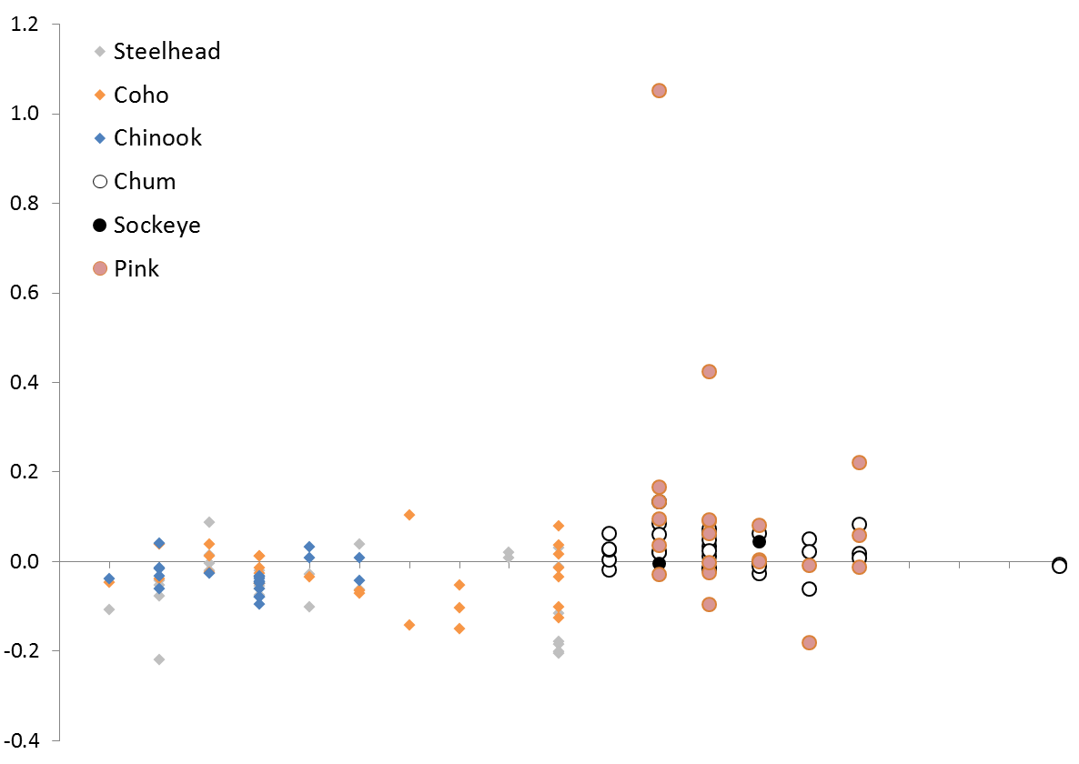

Puget Sound JDF

Strait of

Georgia

JS PC

Population Trend (Holmes 2001)

SS CB HC WB SG CG NS

SS CB HC WB SG CG NS

Puget Sound JDF

Strait of

Georgia

JS PC

Figure 1. Salmon Population trends within the Salish Sea.

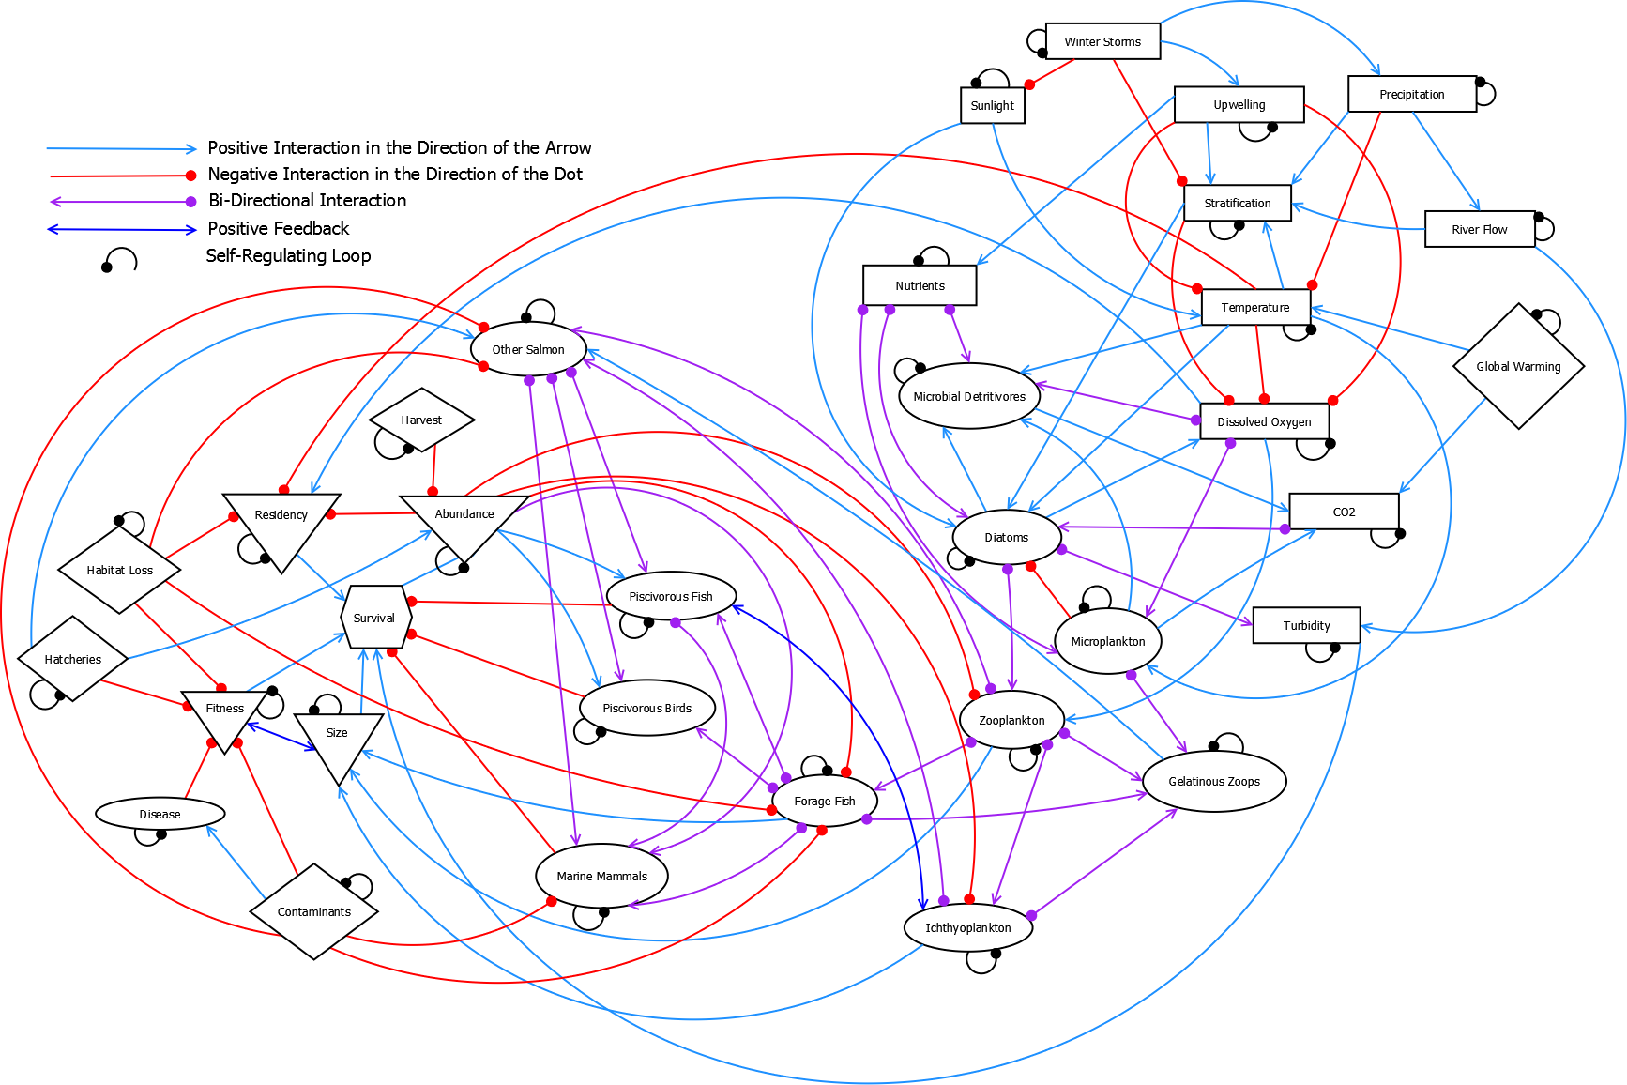

Figure 2. Conceptual directed diagram (digraph) of the Salish Sea related to survival of salmon. Model compartments (shapes) represent foodweb components (ovals), physical drivers (rectangles), anthropogenic impacts (diamonds) and salmon traits of interest (triangles). Survival is shown as a hexagon and was the primary variable of interest. Lines with arrows show positive relationships; lines with filled circles show negative relationships. Small negative loops on model compartments represent self-limiting functions.

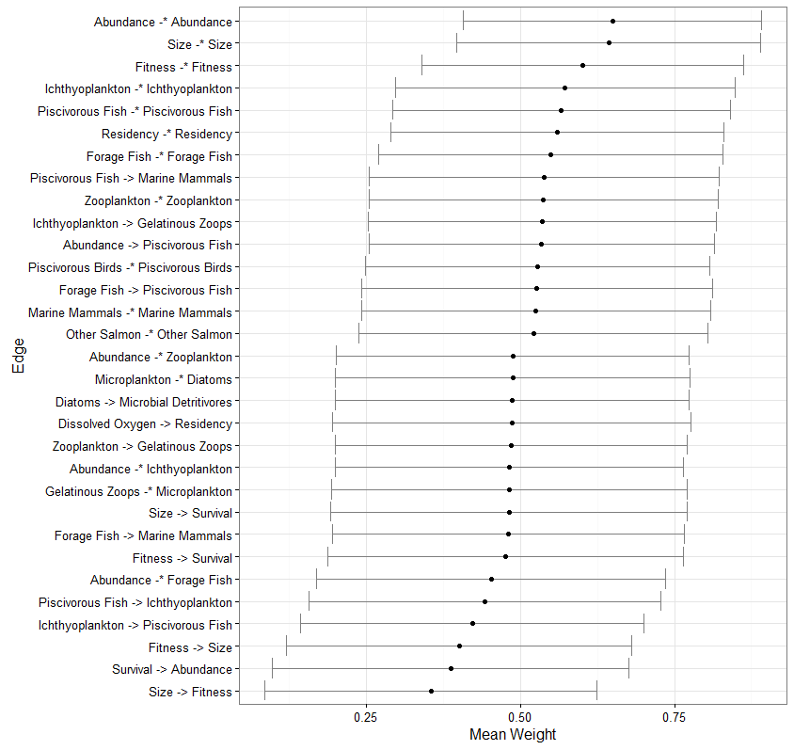

Figure 3. Calculated means and standard deviations for all model runs for edges (model linkages) with mean values different from the expected mean (0.5). The expected mean is denoted by the black line.

Figure 4. Driver group analysis results for the response variables for each of the four groups of drivers. Perturbations were according to Table 3 and in all four figures, negative results are the dark bars and positive results are the light bars. Results are shown for the 10,000 stable models.

Appendix 1. Model Perturbations and References

|  |  |  |  |
| --- | --- | --- | --- |
| **Drivers** | **Variables** | **Reference** | **Invoked Perturbation** |
| *Environmental* | Sunlight |  | ↑ |
|  | Winter Storms |  | ↑ |
|  | Precipitation |  | ↑ |
|  | Upwelling |  | ↓ |
|  | Stratification |  | ↑ |
|  | Temperature | Field et al. 2006, Hollowed et al. 2001 | ↑ |
|  | River Flow |  | ↑ |
|  | Turbidity |  | ↓ |
|  | Dissolved Oxygen |  | ↓ |
| *Production* | Nutrients |  | ↑ |
|  | Microplankton | Moore et al. 2015 | ↑ |
|  | Microbial Detritivores |  | ↑ |
|  | Diatoms |  | ↓ |
| *Foodweb* | Zooplankton |  | ↓ |
|  | Gelatinous Zooplankton | Greene et al. 2015 | ↑ |
|  | Forage Fish | Greene et al. 2015 | ↓ |
|  | Ichthyoplankton |  | ↓ |
|  | Other Salmon |  | ↑ |
|  | Piscivorous Fish |  | ↓ |
|  | Piscivorous Birds |  | ↓ |
|  | Marine Mammals |  | ↑ |
| *Anthropogenic* | Hatcheries |  | ↑ |
|  | Harvest |  | ↑ |
|  | Habitat Loss |  | ↑ |
|  | CO2 | Feely et al. 2010 | ↑ |
|  | Global Warming |  | ↑ |
|  | Contaminants |  | ↑ |
|  | Disease |  | ↑ |

Feely, R. A., S. R. Alin, J. Newton, C. L. Sabine, M. Warner, A. Devol, C. Krembs, and C. Maloy. 2010. The combined effects of ocean acidification, mixing, and respiration on pH and carbonate saturation in an urbanized estuary. *Estuarine, Coastal and Shelf Science*, 88, 442-449, doi:10.1016/j.ecss.2010.05.004

Field, D., D. Cayan, and F. Chavez. 2006. Secular warming in the California current and North Pacific. *California Cooperative Oceanic Fisheries Investigations Reports*, 47, 92-108.

Hollowed, A. B., S. R. Hare, and W. S. Wooster. 2001. Pacific Basin climate variability and patterns of Northeast Pacific marine fish production. *Progress in Oceanography*, 49, 257-282, doi:10.1016/S0079-6611(01)00026-X.

Moore, S.K. et al., 2011. Past trends and future scenarios for environmental conditions favoring the accumulation of paralytic shellfish toxins in Puget Sound shellfish. *Harmful Algae*, 10, 521-529.

Moore, S.K. et al., 2015. Present-day and future climate pathways affecting the harmful algal blooms species *Alexandrium catenella* in Puget Sound, WA, USA. *Harmful Algae*, 48, 1-11. 25

Appendix 2. Model Output for Individual Perturbations

Model output showing 6 model nodes of interest: Salmon Survival, Salmon Abundance, Salmon Size, Residency, Fitness and Other Salmon. Other Salmon refers to the populations (chum, pink, and sockeye) which have not seen a noticeable decline in survival in recent decades. In each plot box, the model node that was “pressed” is shown in the title, with the direction of the press (Increase or Decrease) shown below. The bar graphs indicate the proportion of model simulations with negative (red bars) and positive (blue bars) outcomes for that model node given the invoked press perturbation. Where the bars are dark gray, there was no impact to those nodes.

